David McCahon

40214392

Guesthouse coursework

INF08104 DATABASE SYSTEMS

Contents

Section 1 2

Question 1 2

Question 6 2

Question 7 2

Question 8 3

Question 9 3

Section 2 4

Entity Relationship Diagram 4

Add Payment Table 5

Add Card Details 5

Populate Payment Table 6

VAT Add 6

# Section 1

## Question 1

http://puu.sh/rAAwZ/31f78d4df0.png

SELECT

booking_date, nights

FROM

booking

WHERE

guest_id = 1183

## Question 6

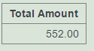

SELECT

SUM((nights * amount)) AS 'Total Amount'

FROM rate

JOIN

booking ON (rate.room_type = booking.room_type_requested AND rate.occupancy = booking.occupants)

JOIN

guest ON (guest.id = booking.guest_id)

WHERE

last_name = "Cadbury" AND first_name = "Ruth"

GROUP BY guest_id

## Question 7

http://puu.sh/rN90G/e053c9374d.png

SELECT

SUM((rate.amount * booking.nights) + extra.amount) AS 'Rate Amount'

FROM booking

JOIN

rate ON (rate.room_type = booking.room_type_requested AND rate.occupancy = booking.occupants)

JOIN

extra ON (booking.booking_id = extra.booking_id)

WHERE booking.booking_id = 5128

GROUP BY booking.booking_id

## Question 8

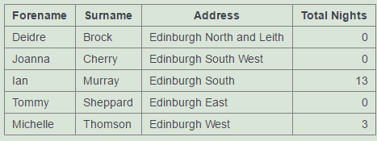

SELECT

first_name AS Forename, last_name AS Surname, address AS Address, coalesce(SUM(nights),0) AS 'Total Nights' FROM booking

RIGHT JOIN

guest ON (guest.id = booking.guest_id)

WHERE address LIKE ('%Edinburgh%')

GROUP BY guest_id, address, first_name, last_name

ORDER BY last_name, first_name

## Question 9

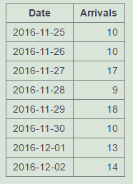

SELECT

booking_date AS Date, SUM(occupants) AS "Arrivals"

FROM booking

WHERE

booking_date BETWEEN "2016-11-25" AND "2016-12-02"

GROUP BY booking_date

# Section 2

## Entity Relationship Diagram



## Add Payment Table

CREATE TABLE payment_type

(

id INT(3) NOT NULL PRIMARY KEY,

type VARCHAR(50) NOT NULL

);

CREATE TABLE payments

(

id int(11) NOT NULL PRIMARY KEY,

booking_id INT(11) NOT NULL,

type_id INT(3) NOT NULL,

date DATE NOT NULL,

amount FLOAT NOT NULL,

FOREIGN KEY(booking_id) REFERENCES booking(booking_id),

FOREIGN KEY (type_id) REFERENCES payment_type(id)

);

ALTER TABLE booking

ADD COLUMN payment_id int(11),

ADD CONSTRAINT `payment_id` FOREIGN KEY (`payment_id`)

REFERENCES `payments`(`id`);

INSERT INTO payment_type

(id, type)

VALUES

('1', 'Debt Card'),

('2', 'Cash');

## Add Card Details

UPDATE guest SET ccnum='1345678903241257'

WHERE id =1343;

UPDATE guest SET ccnum='6784325690834789'

WHERE id=1597;

## Populate Payment Table

INSERT INTO payments

(id, booking_id, type_id, date, amount)

VALUES

('53601', '5360', '1', '2016-12-11', 216),

('53591', '5359', '1', '2016-11-20', 288),

('53592', '5359', '2', '2016-11-27', 49.06);

UPDATE booking

SET payment_id = '53601'

WHERE booking_id = 5360;

UPDATE booking

SET payment_id = '53591'

WHERE booking_id = 5359;

## VAT Add

ALTER TABLE extra

ADD COLUMN VAT float;

ALTER TABLE extra

ADD COLUMN excl_vat float;

ALTER TABLE extra

DROP column total;

UPDATE extra

SET VAT =

extra.amount(extra.amount / 1.20))

WHERE

extra.description LIKE "Phone%";

UPDATE extra

SET excl_vat = extra.amount - Vat;

ALTER TABLE rate

ADD COLUMN vat float;

ALTER TABLE rate

ADD COLUMN excl_vat float;

UPDATE rate

SET vat = (amount -(rate.amount / 1.20));

UPDATE rate

SET excl_vat = amount - vat